**GLASGOW DISABILITY TENNIS VI TENNIS COACHING**

**DATES:** **Tuesdays**

**TIME:** **5pm to 6.30pm**

**VENUE: Gorbals Tennis Centre, 275 Ballater Street, Glasgow, G5 0YP**

**WHAT:** **Coaching & fun games**

**AGE:**  **8 years upwards**

**COST:** **£6.00 per week**

**LEVEL:** **All abilities**

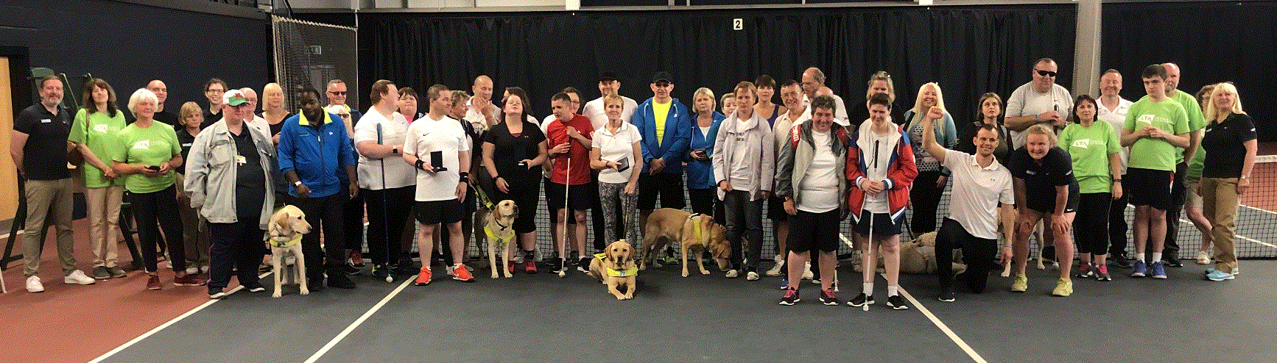

Come along and have a go and make new friends. The coaching sessions are organised by Glasgow Disability Tennis is an LTA Open Court venue, in partnership with Tennis Scotland, Disability Sport Glasgow & Glasgow Sport.

Everyone who attends will be able to learn at their own ability level. For younger players we use fun equipment to aid improvement & help you succeed

The sessions are run by LTA qualified coaches. All equipment provided.

To book a place on Glasgow Disability Tennis Visually Impaired tennis coaching, contact Lesley Whitehead on 07590 901678

**Glasgow Disability Tennis are winners of Tennis Scotland Disability Programme of the Year & LTA Disability Club of the Year**

**OSCR Registered Charity – SC045479**

**GLASGOW DISABILITY TENNIS VI TENNIS COACHING**

**DATES:** **Tuesdays**

**TIME:** **5pm to 6.30pm**

**VENUE: Gorbals Tennis Centre, 275 Ballater Street, Glasgow, G5 0YP**

**WHAT:** **Coaching & fun games**

**AGE:**  **8 years upwards**

**COST:** **£6.00 per week**

**LEVEL:** **All abilities**



Come along and have a go and make new friends. The coaching sessions are organised by Glasgow Disability Tennis is an LTA Open Court venue, in partnership with Tennis Scotland, Disability Sport Glasgow & Glasgow Sport.

Everyone who attends will be able to learn at their own ability level. For younger players we use fun equipment to aid improvement & help you succeed

The sessions are run by LTA qualified coaches. All equipment provided.

To book a place on Glasgow Disability Tennis Visually Impaired tennis coaching, contact Lesley Whitehead on 07590 901678

**Glasgow Disability Tennis are winners of Tennis Scotland Disability Programme of the Year & LTA Disability Club of the Year**

**OSCR Registered Charity – SC045479**